ASSESSMENT 2

*“INTRODUCTION TO DATABASE MANAGEMENT SYSTEM & SQL COMMANDS”*

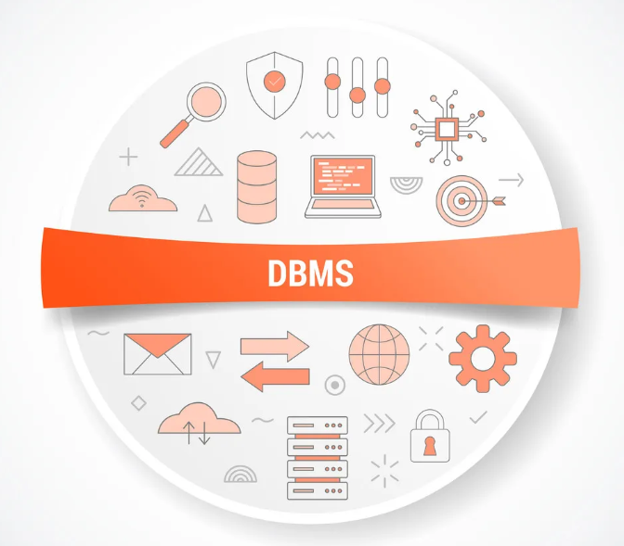

Submitted By

VAIBHAV PATIDAR

IPS ACADEMY, INDORE (M.P.)

**→ What is SQL?**

* SQL stands for “Structured Query Language”.
* It works with relational databases, and store data in form of rows and columns in tabular form.
* SQL is easy, versatile and powerful in working with transactional data.

→ **Different types of Database**

1. Relational Database
2. Operational Database
3. Databse Warehouse
4. Distributed Databases
5. End-User Databases.

→ **What is Relational Database?**

* A relational database, works on two important properties of SQL i.e. Tables and data relations.
* The structure of table containing rows and columns is known as schema.
* In relational database, we can easily connect multiple tables, by using the same key from both the tables.

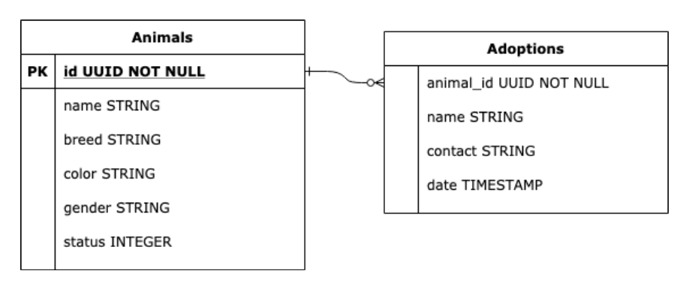

**→ Types of SQL Language Statements**

1. **DDL (Data Definition Language) :** It defines the structure of the database using commands CREATE and ALTER. It also controls the accessing of the data.
2. **DML (Data Manipulation Language) :** It allows us to manipulate the data. It provides commands like SELECT, INSERT, UPDATE and DELETE for managin, adding, changing and removing data from the table.
3. **DML (Data Control Language) :** It allows us to manage the permissions like, who can access our database. It also shows the list of tables and permissions.

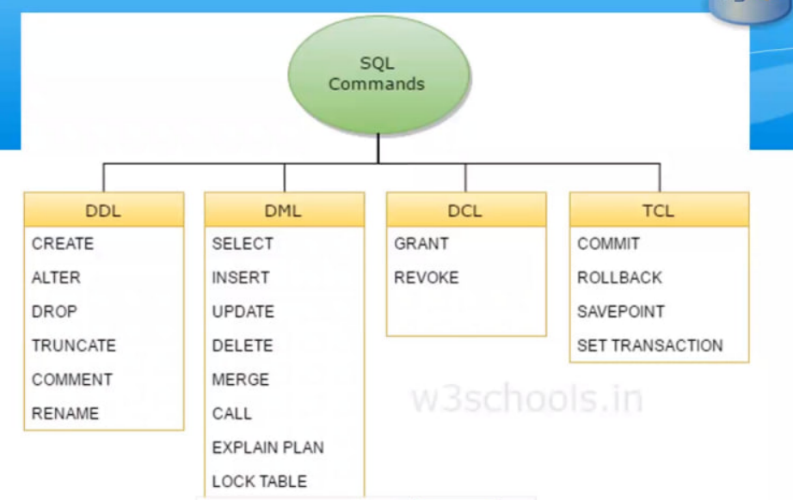

**Creating a table “pet_animals” using CREATE command [DDL]:**

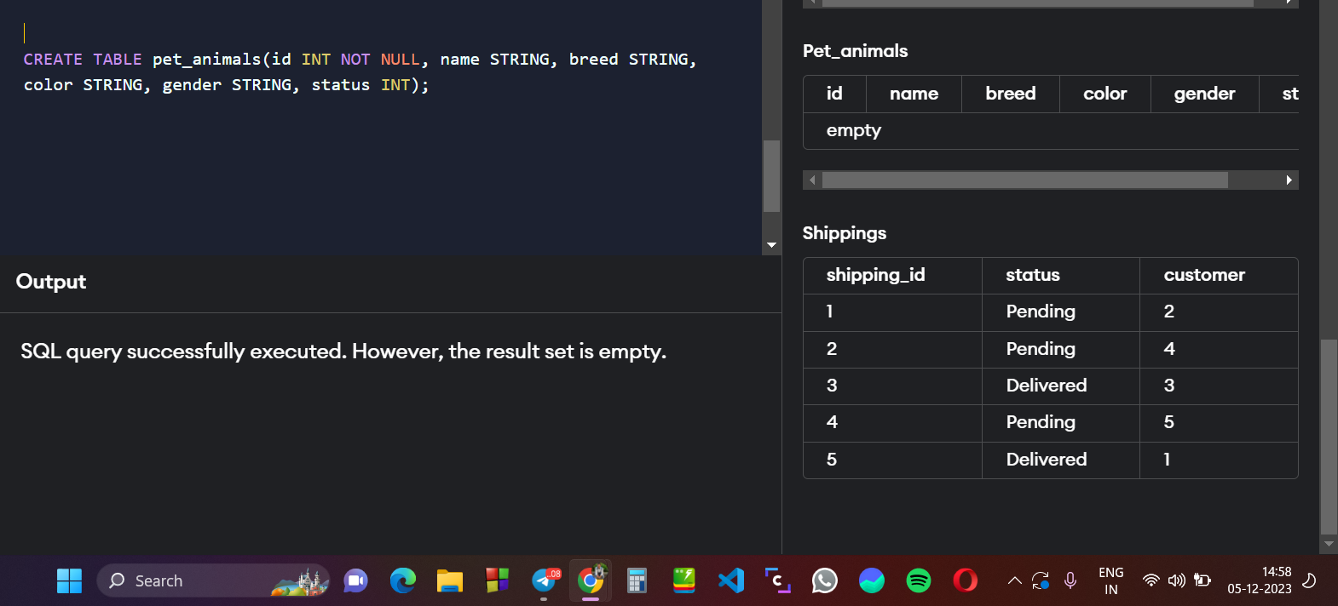

**Creating a table for Adoption Details using CREATE Command [DDL] :**

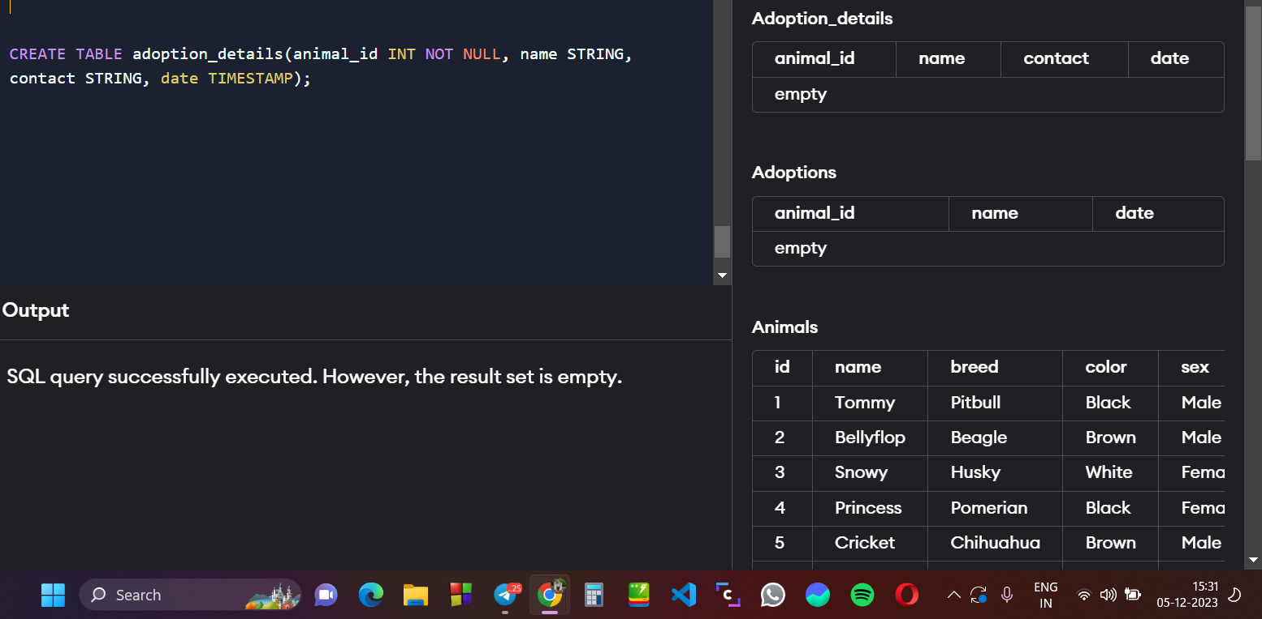

**Inserting the details of all dogs using INSERT Command [DML]:**

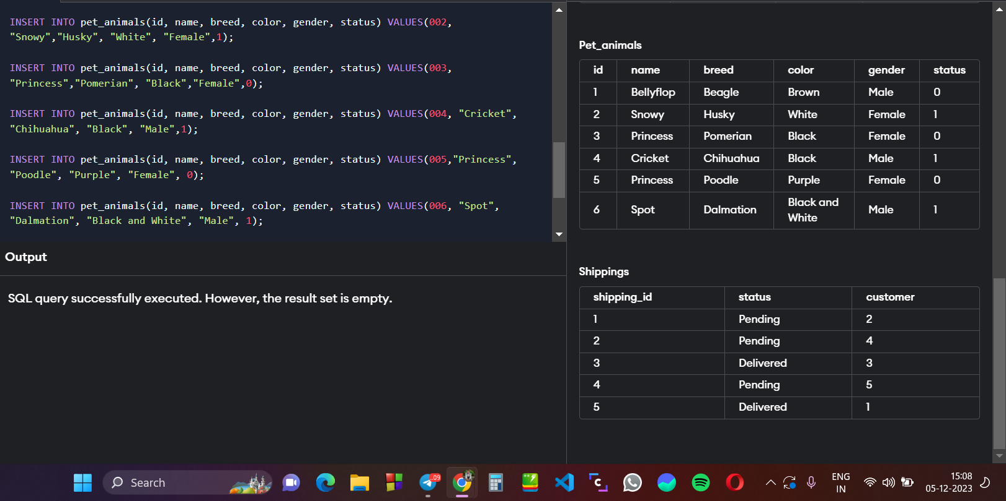

**Retrieving list of all dogs using SELECT * Command [DML] :**

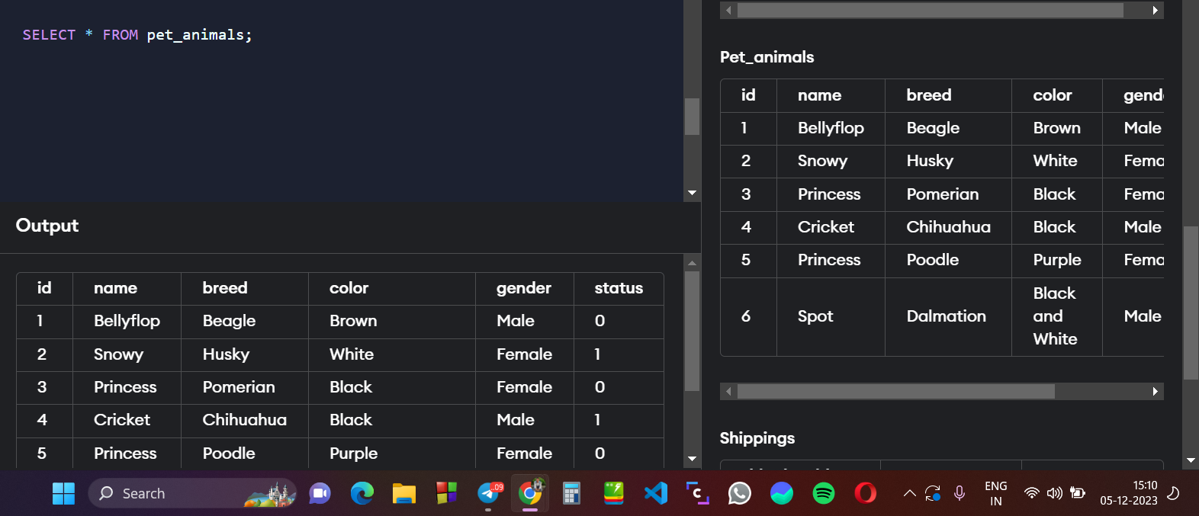

**Listing the Dogs available for adoption using SELECT & WHERE Clause [DML]:**

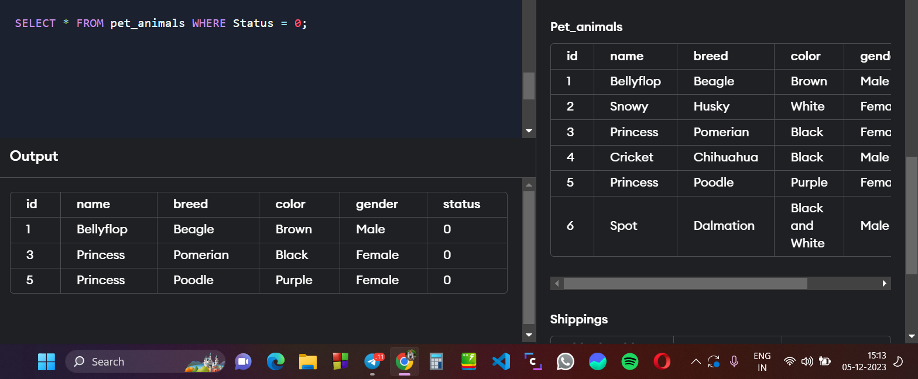

**Update the color of Princess to brown using UPDATE , SET & WHERE Command [DML] :**

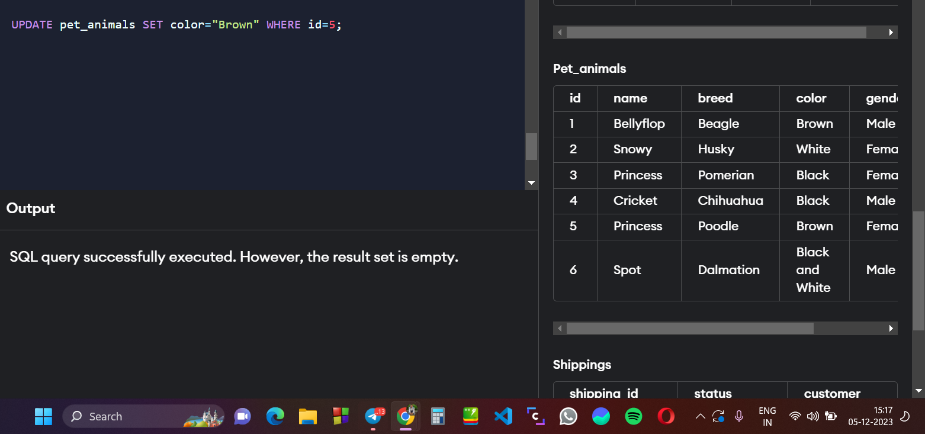

**Updating the adoption_details table for Princess (Poodle) and Spot (Dalmation) as they are adopted - using UPDATE, SET, WHERE & INSERT Command :**

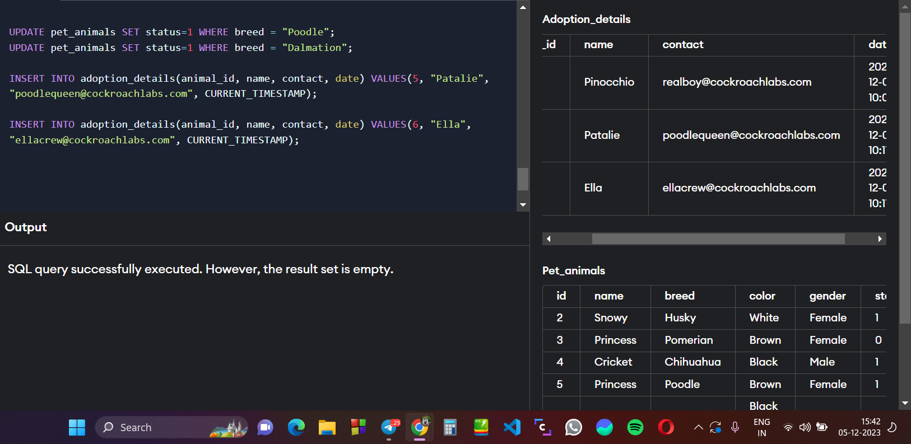

**Deleting the Bellyflop dog details from the table using DELETE Command [DML] :**

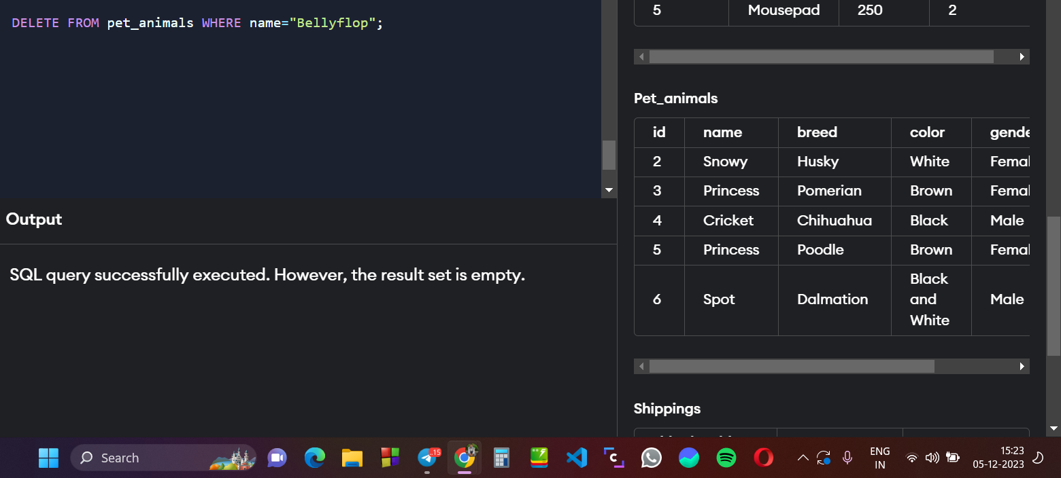

**Changing the status of Snowy to 1 as it is Adopted using UPDATE Command [DML] :**

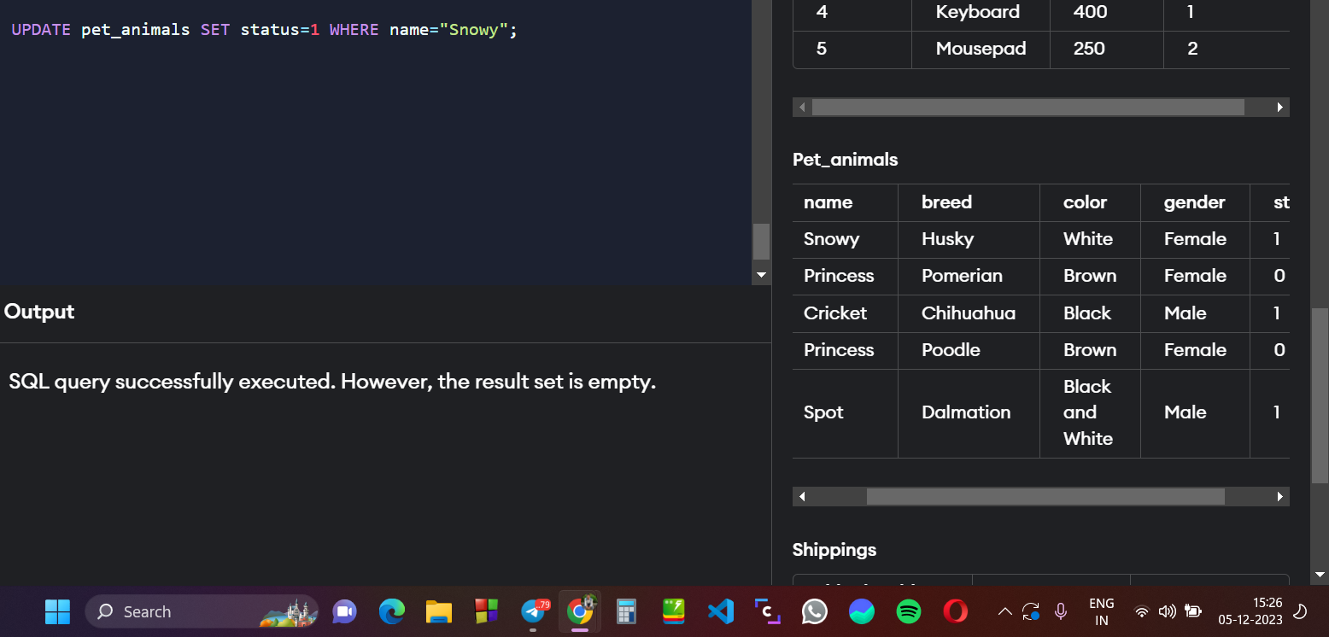

**Adding new column for Cats in pet_animals table using ALTER Command [DDL] :**

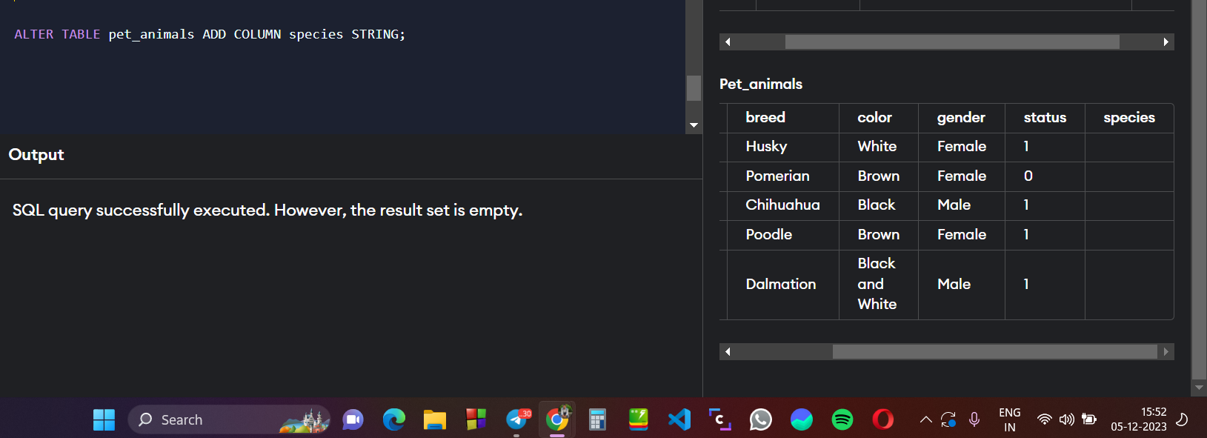

**SET all current animals as dog using UPDATE & SET Command [DML]:**

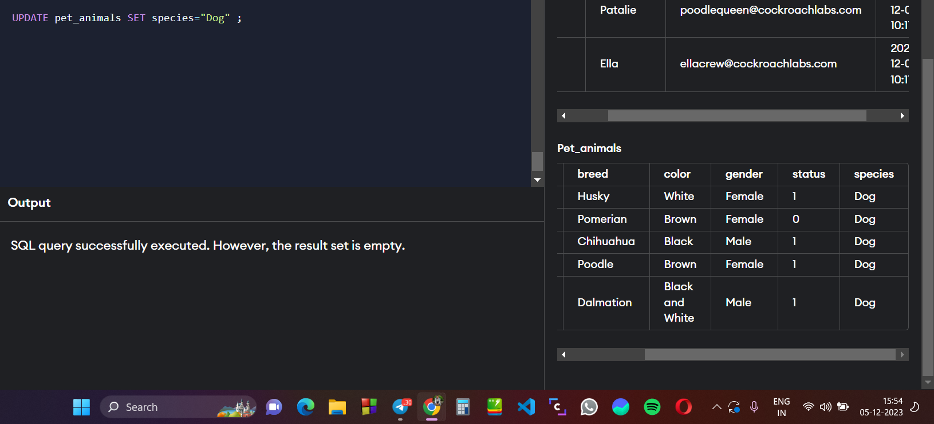

**Adding 3 Cat details to the pet_animals table using INSERT Command [DML] :**

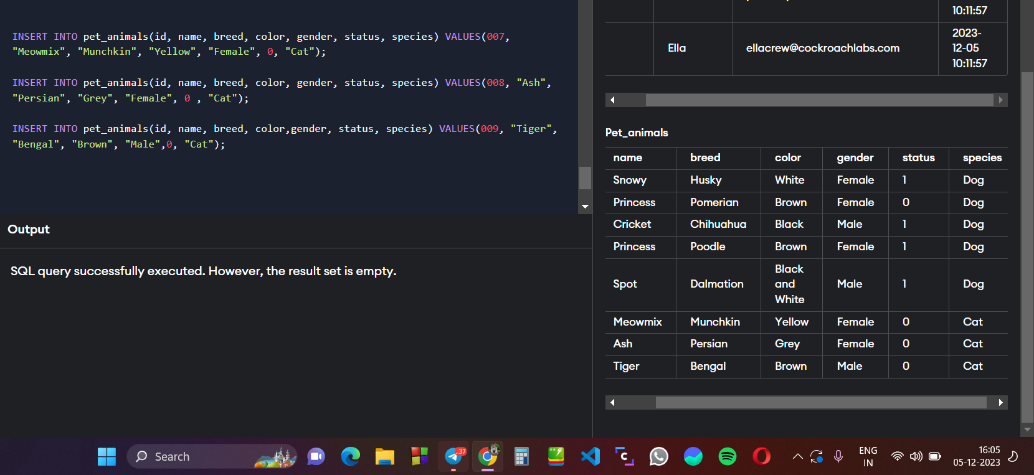

**Deleting Shelters table data using DELETE Command [DML] :**

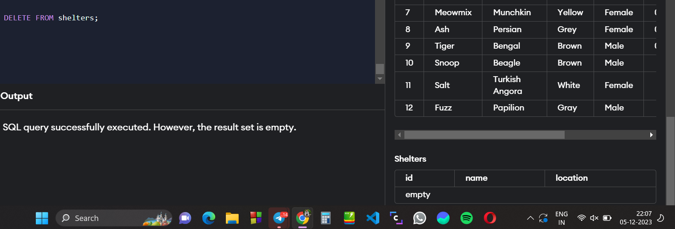

**Changing the table name “SHELTERS” → “NEW_SHELTERS” using RENAME Command [DDL] :**

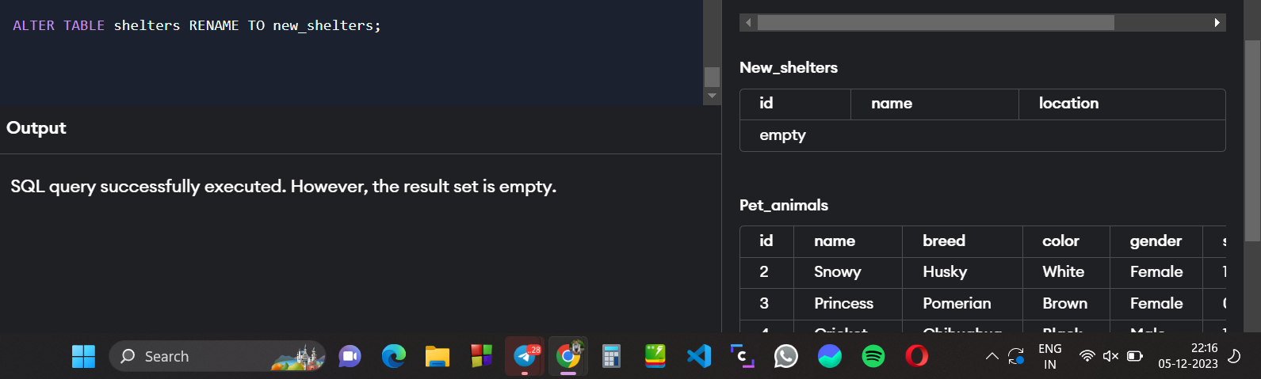

**Visit also :**

[**ASSESSMENT 2 : SQL COMMANDS ONLY**](https://docs.google.com/document/u/0/d/1aNo4gTPT5gR_6wiCFe84Wm1s94KPUc_tlb2U4faMLLE/edit)